**Issue**8|77770005| Router Disconnect order must use Order Eff Date greater date than XXXX

**Referral ticket Number:** 256671970, 270014588

**Order:** 194708045

How we pick the Ticket in AOTS exclude HOTCUT Tickets and pick up only Queued tickets?

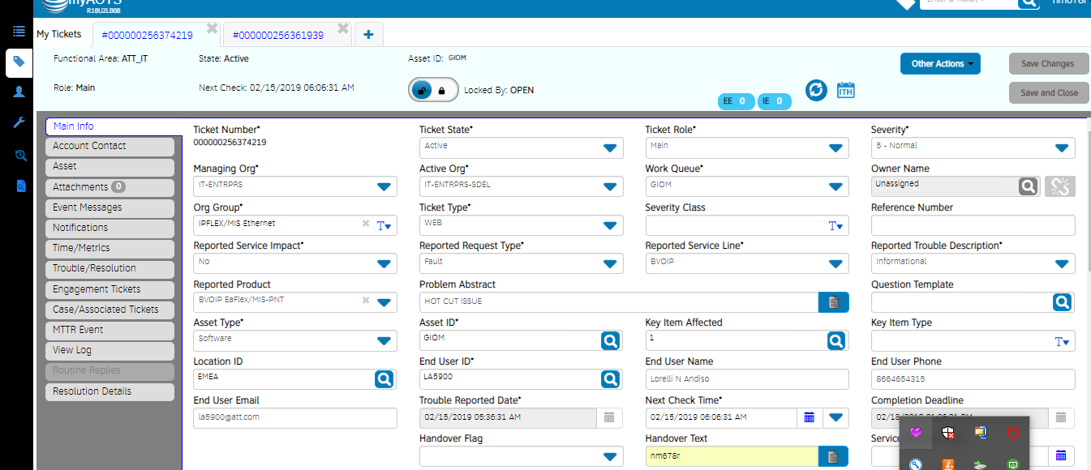

Step 2

Step 1

Step 4

Step 3

## Step 1: Put the ATT UID in handover text.

## Step 2: Select Informational from Reported Trouble Description

## Step 3: Locked the ticket

## Step 4: Save it

How to pick order?

## Step 5: Order is present in main ticket info under Order_number field or in Problem Description.

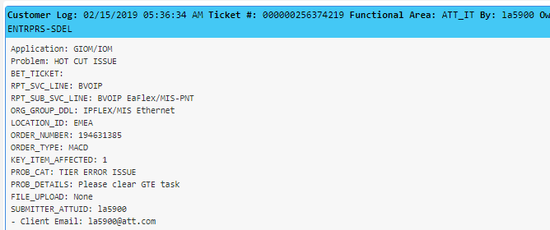

## Step 6: Step 6:Check through EFMS or BVOIP Tool.

## 6.1 Go to EFMS GUI

<http://efmsms.it.att.com:8008/ms>

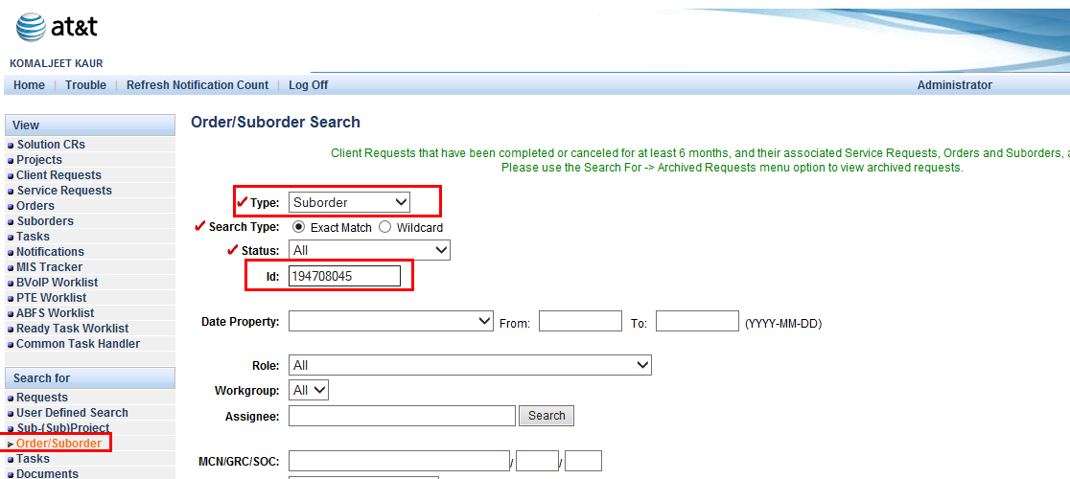

Follow the below steps to check error message and also highlighted main tabs in above screen shot.

1. Click on **Order/Suborder** from “**Search For**”.
2. Select **Suborder** from **Type** filed.
3. Put **order number** in **ID**: field.
4. And click on **Find** Button



1. Select the radio button corresponding to GTE task and click on Open tab as shown below.

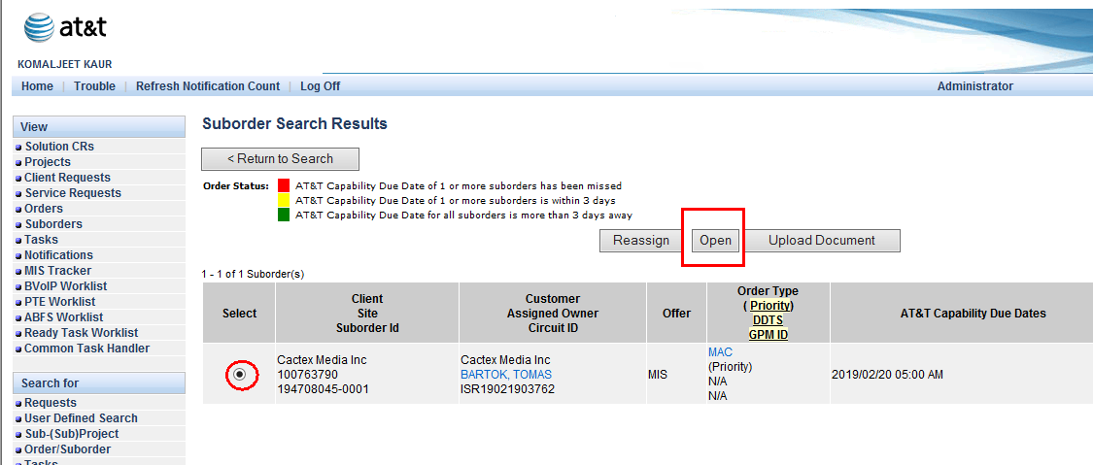

1. Once next screen gets open click on **Suborder Tasks** and then select **Expanded** from **Views** field and click on **Open Task**.

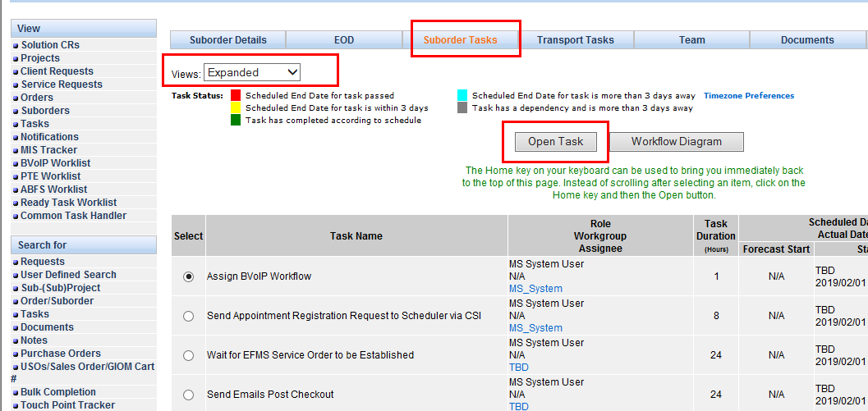

1. Click on Activity Log as shown below

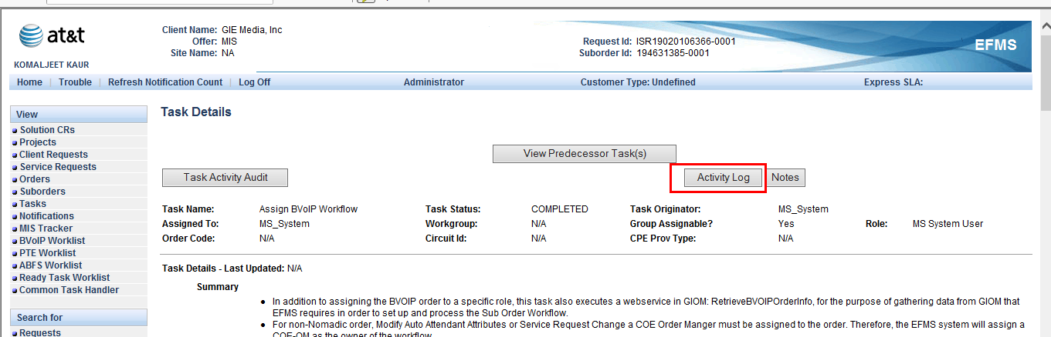

1. You will get below screen

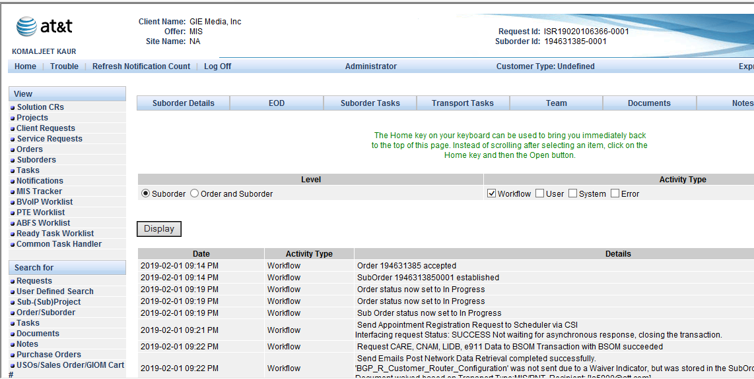

1. Scroll down as and see error message as shown below in screen shot.

VOIP Service Error <p> ROUTER Group - this error is related to add, change, disconnect of Router and its related groups </p> <p> CADM Database: Failed to end-date Router and related classes for Router Number &#60xxx&#62.- please contact CADM production support. </p>

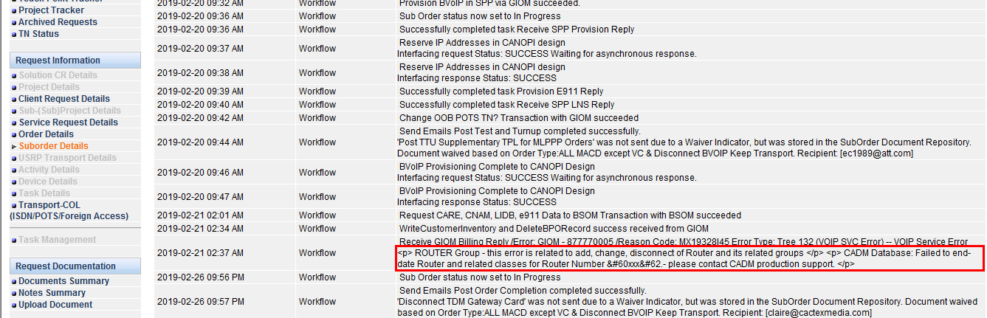

## 6.2 Go to BVOIP Order Status Tool to view the GIOM Tier Error on Order.

Link of BVOIP Order Status Tool:

http://giom.cif.att.com:9001/JSP/voip/jsp/tools/BvoipToolsMain.jsp

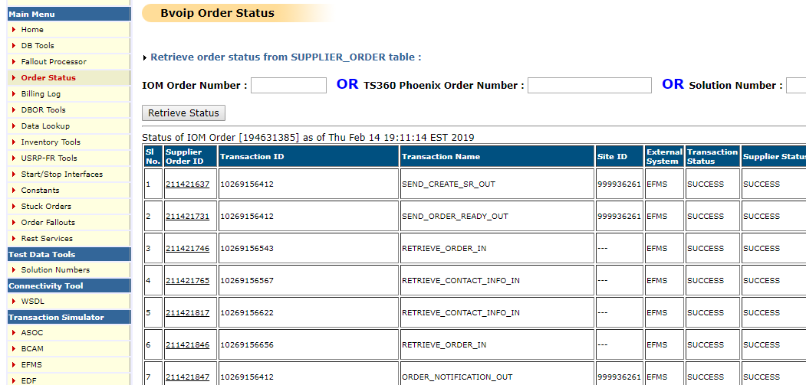

**Step 9**

**Step 8**

**Step 7**

## Step 7: Select Order Status from Main menu

## Step 8: Put the Order Number in IOM Order Number text box.

## Step 9: click on retrieve Status and scroll down to the Billing transactions.

Billing Transactions for the old flow:

SEND_BSE_OUT

SEND_RSC_OUT

SEND_BTF_OUT

PROCESS_BTN_REQUEST

SEND_BTN_OUT  
PROCESS_BTN_RESPONSE

SEND_BILLING_RESULT_BVOIP_OUT

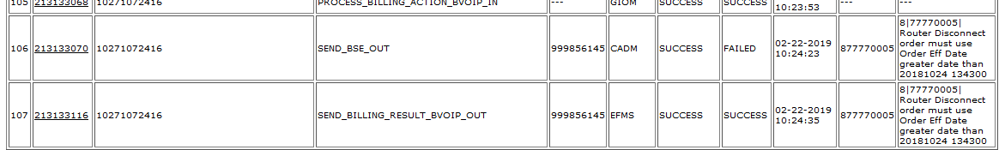

**Error message**

## Step 10: Copy the date from Error Message

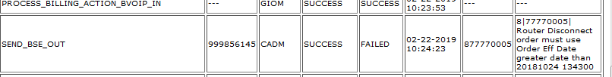

**Step 10**

## Step 11: **Step1:**Billing Date=Billingeffectivedate(from error message corresponding to Order Eff Date greater date than )+1.

### Step2**:** Update the EFMS DB with Billing date from Step1 for order.

DB Details –

Host Name- p1efm1d7.aldc.att.com

Port – 1524

update ms_order set billing_effective_date = todate('06-FEB-19','DD-MON-YY') where usrp_order_number = ‘ordernumber’;

### **Step3:** Force Complete the GIOM Tier Error task

If there are multiple GTEs, the latest GTE need to be force completed.

1. cd /opt/app/home/prodsupp/complete  
  
 2. fc.run (script name)

Please refer below M&P for FC



*Reference to Mnp where task are skipped and fcd*

**Note - Once task is force completed, it can’t be undone.**

#### 

## Step 12:- Need to re-validate from BVOIP for success or failure for error. If it is a success go to Step5.

Check below transaction if they are successful

SEND_BSE_OUT

SEND_RSC_OUT

SEND_BTF_OUT

PROCESS_BTN_REQUEST

SEND_BTN_OUT

PROCESS_BTN_RESPONSE

SEND_BILLING_RESULT_BVOIP_OUT

In case of failure and same error_code is same then start from step2, else mark it as RED in USH/AOTS.

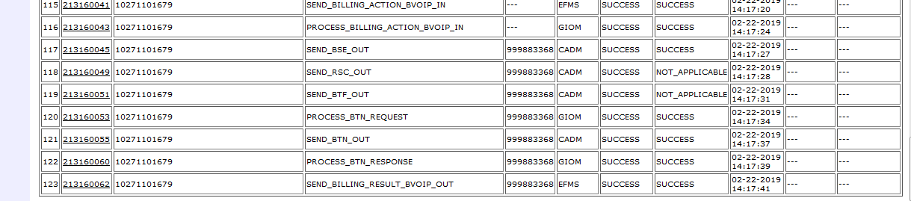

1. If billing is success and GTE are still present in EFMS, Iskip GTE.

Please Refer Below M&P for Iskip

**Note - Once task is iskipped, it can’t be undone.**

ISSUE RESOLVED.